Practice Arrays

1.Program to print an array

#include <stdio.h>

int main()

{

int Array[50], i, Number;

printf("\nPlease Enter Number of elements in an array : ");

scanf("%d", &Number);

printf("\nPlease Enter %d elements of an Array \n", Number);

for (i = 0; i < Number; i++)

{

scanf("%d", &Array[i]);

}

printf("\n Elements in this Array are :\n");

for (i = 0; i < Number; i++)

{

printf("%d\n", Array[i]);

}

return 0;

}

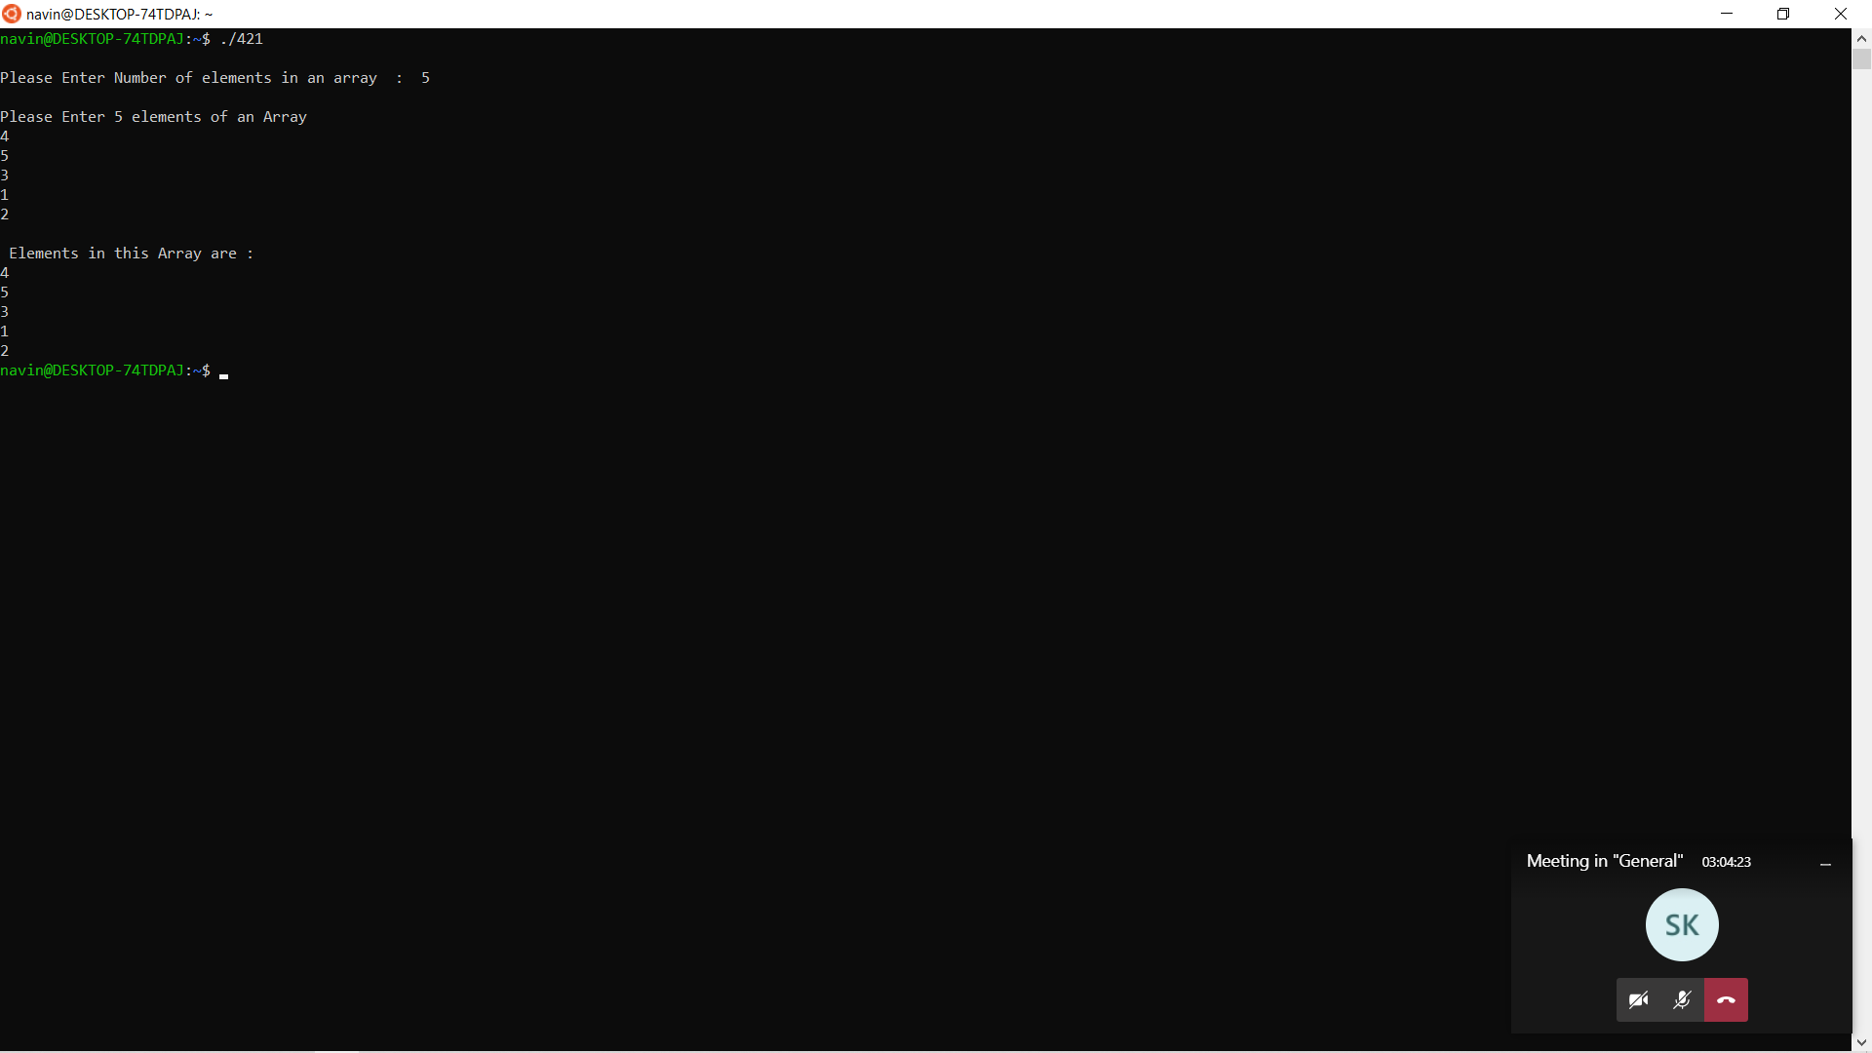

2.Program to print an array in reverse order

#include <stdio.h>

int main()

{

int n, c, d, a[100], b[100];

printf("Enter the number of elements in array\n");

scanf("%d", &n);

printf("Enter array elements\n");

for (c = 0; c < n ; c++)

scanf("%d", &a[c]);

/\*

\* Copying elements into array b starting from end of array a

\*/

for (c = n - 1, d = 0; c >= 0; c--, d++)

b[d] = a[c];

/\*

\* Copying reversed array into the original.

\* Here we are modifying original array, this is optional.

\*/

for (c = 0; c < n; c++)

a[c] = b[c];

printf("Reverse array is\n");

for (c = 0; c < n; c++)

printf("%d\n", a[c]);

return 0;

}

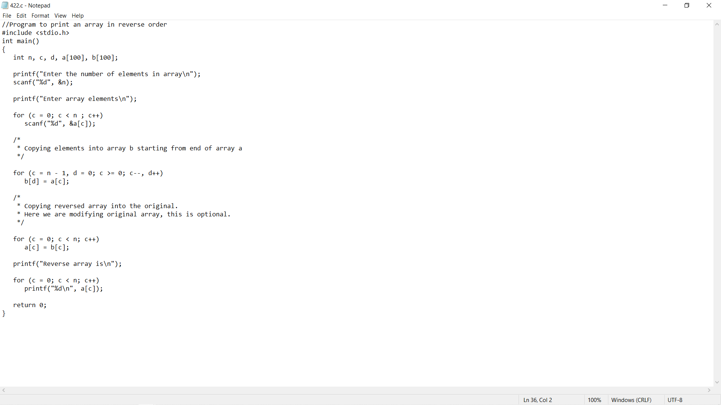

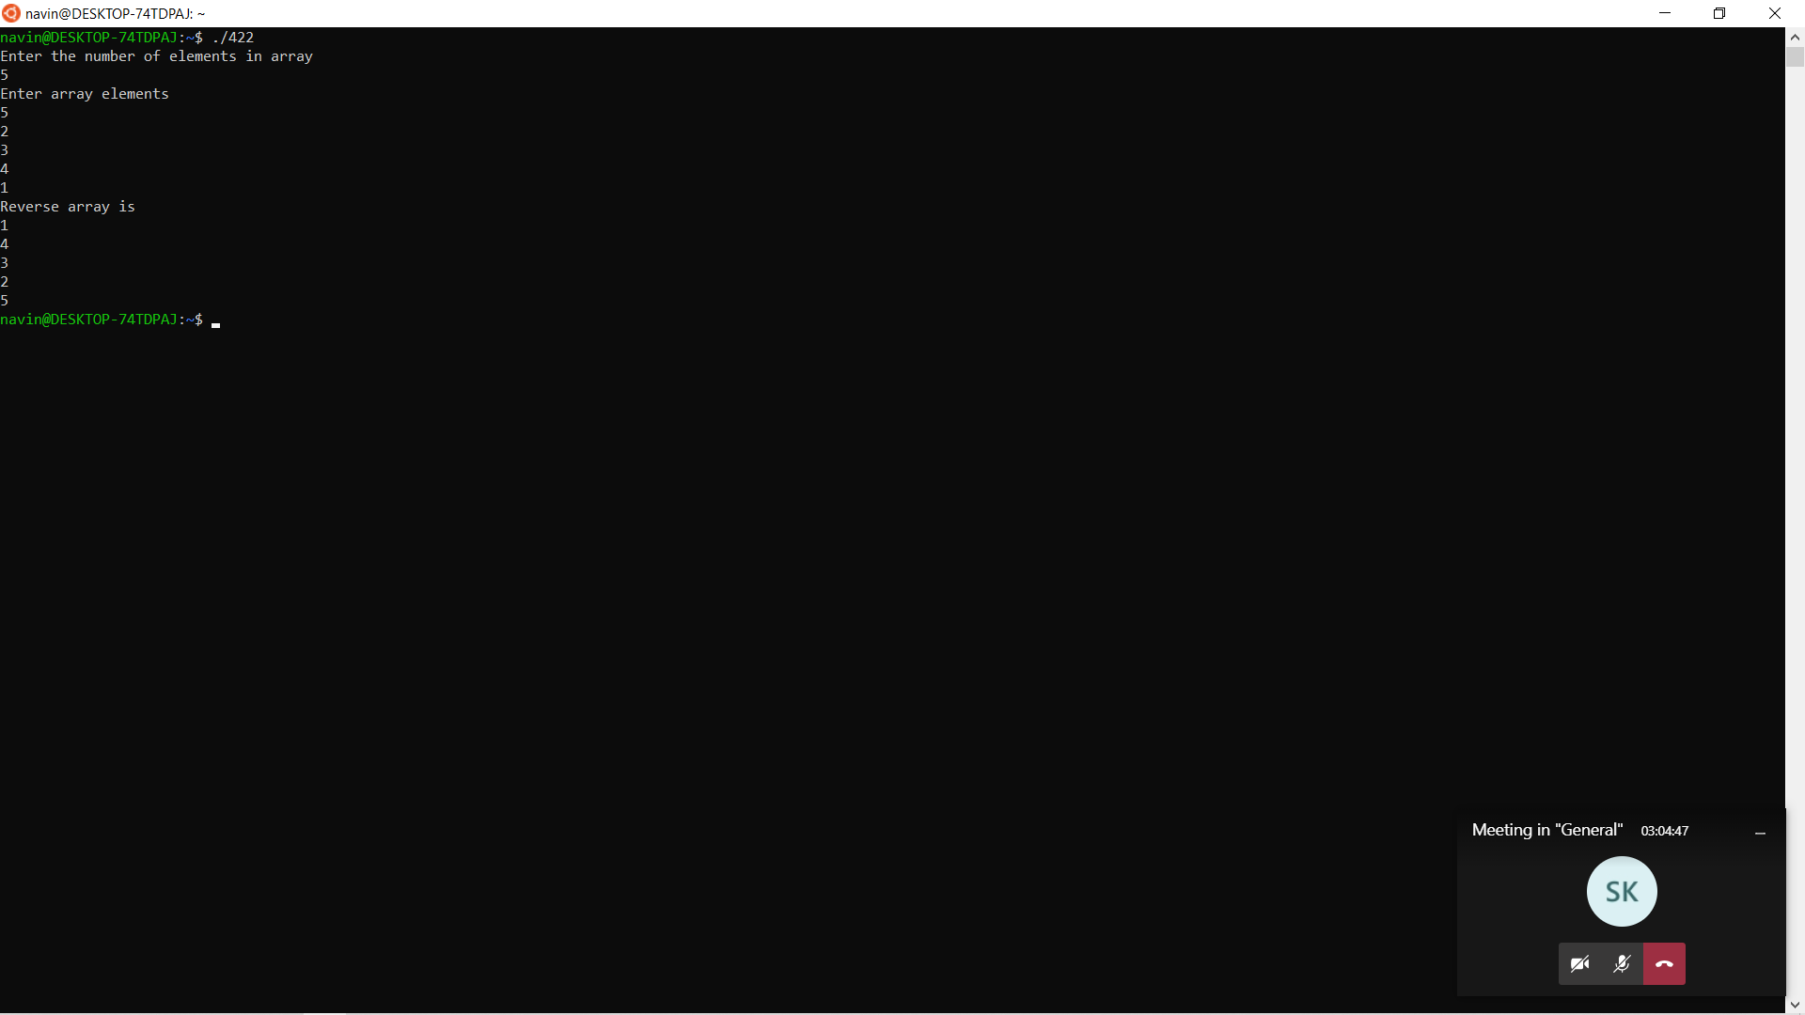

3.Program to calculate sum of an array

#include <stdio.h>

void main()

{

int a[100];

int i, n, sum=0;

printf("\n\nFind sum of all elements of array:\n");

printf("--------------------------------------\n");

printf("Input the number of elements to be stored in the array :");

scanf("%d",&n);

printf("Input %d elements in the array :\n",n);

for(i=0;i<n;i++)

{

printf("element - %d : ",i);

scanf("%d",&a[i]);

}

for(i=0; i<n; i++)

{

sum += a[i];

}

printf("Sum of all elements stored in the array is : %d\n\n", sum);

}

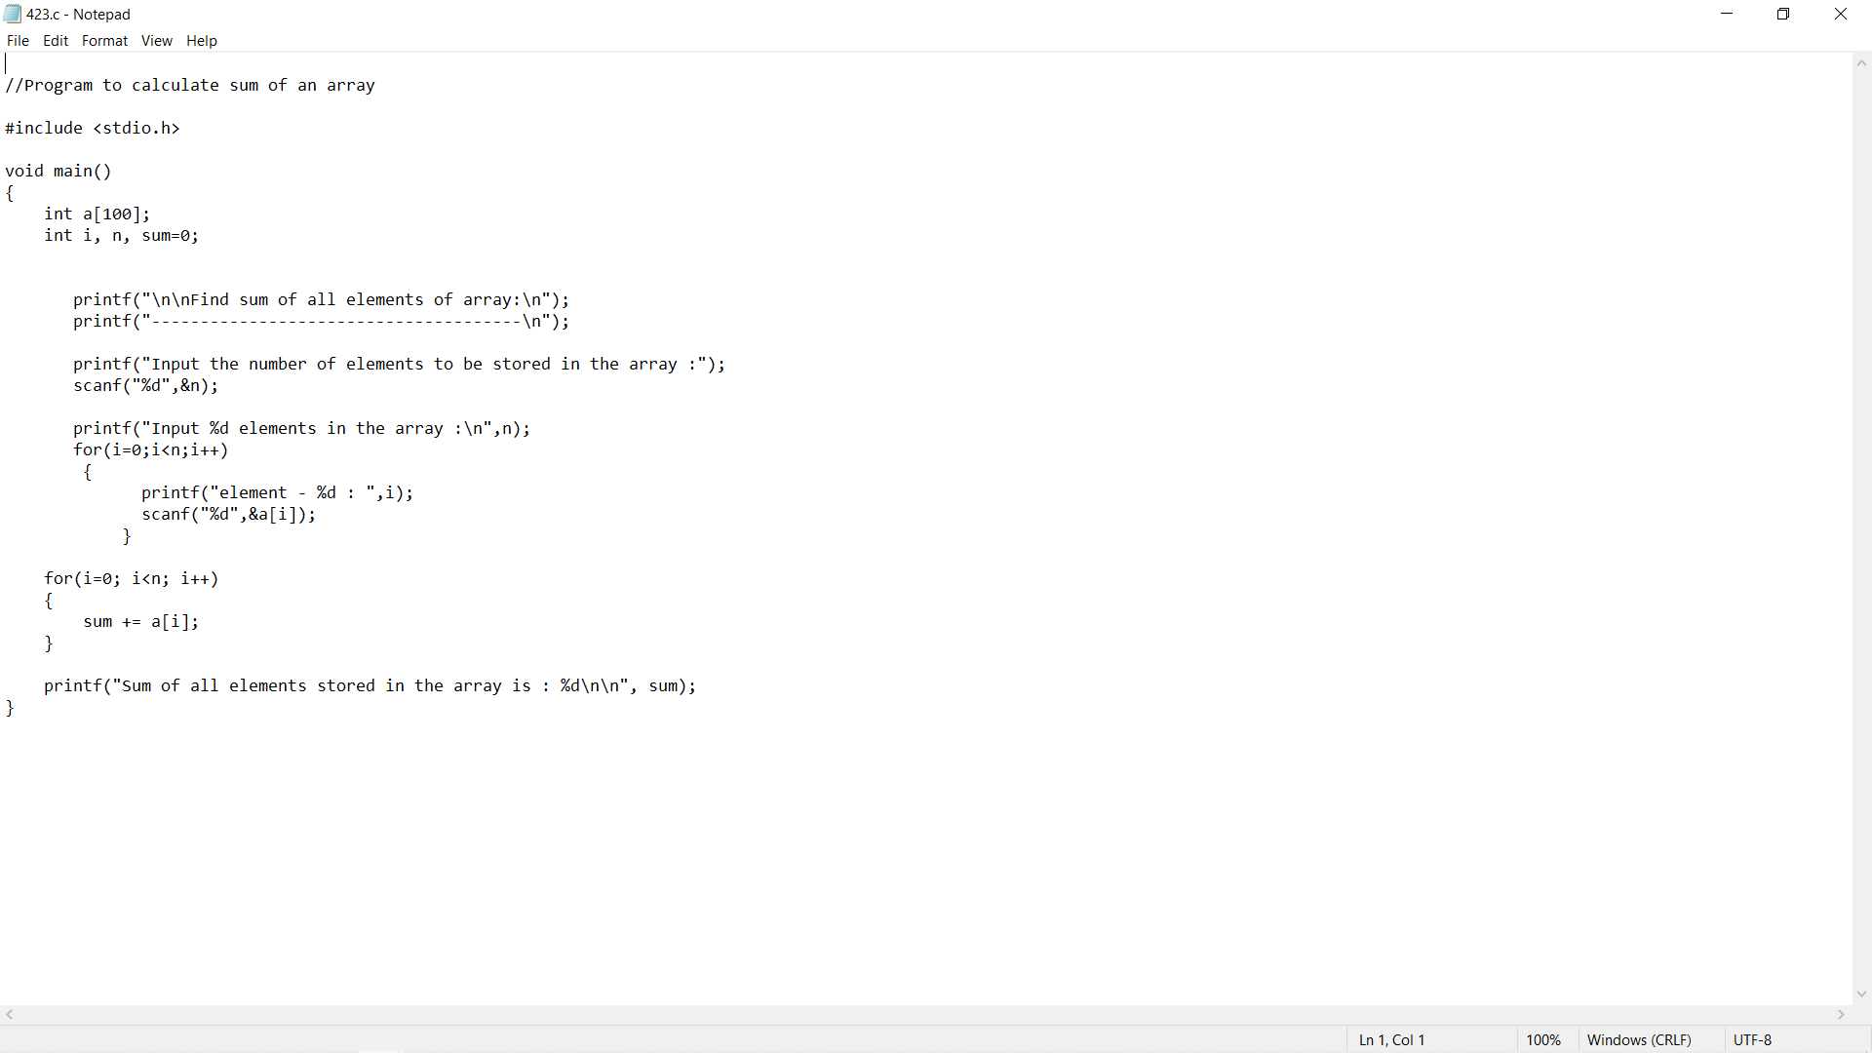

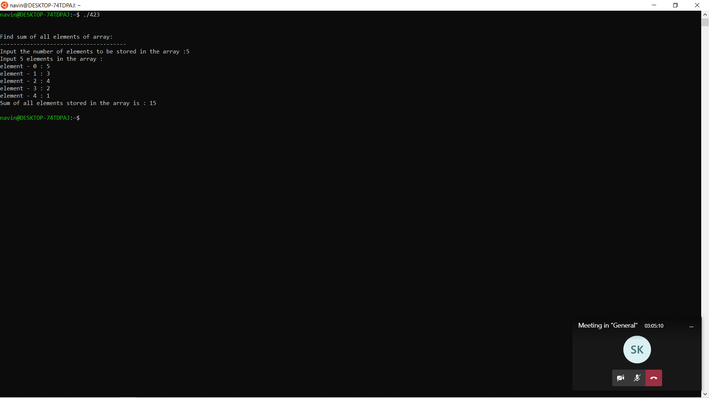

4.Program to calculate average of an array

#include <stdio.h>

int main() {

int n, i;

float num[100], sum = 0.0, avg;

printf("Enter the numbers of elements: ");

scanf("%d", &n);

while (n > 100 || n < 1) {

printf("Error! number should in range of (1 to 100).\n");

printf("Enter the number again: ");

scanf("%d", &n);

}

for (i = 0; i < n; ++i) {

printf("%d. Enter number: ", i + 1);

scanf("%f", &num[i]);

sum += num[i];

}

avg = sum / n;

printf("Average = %.2f", avg);

return 0;

}

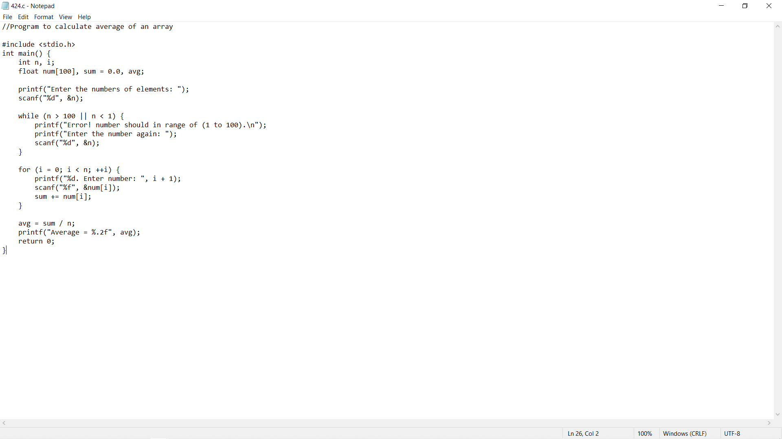

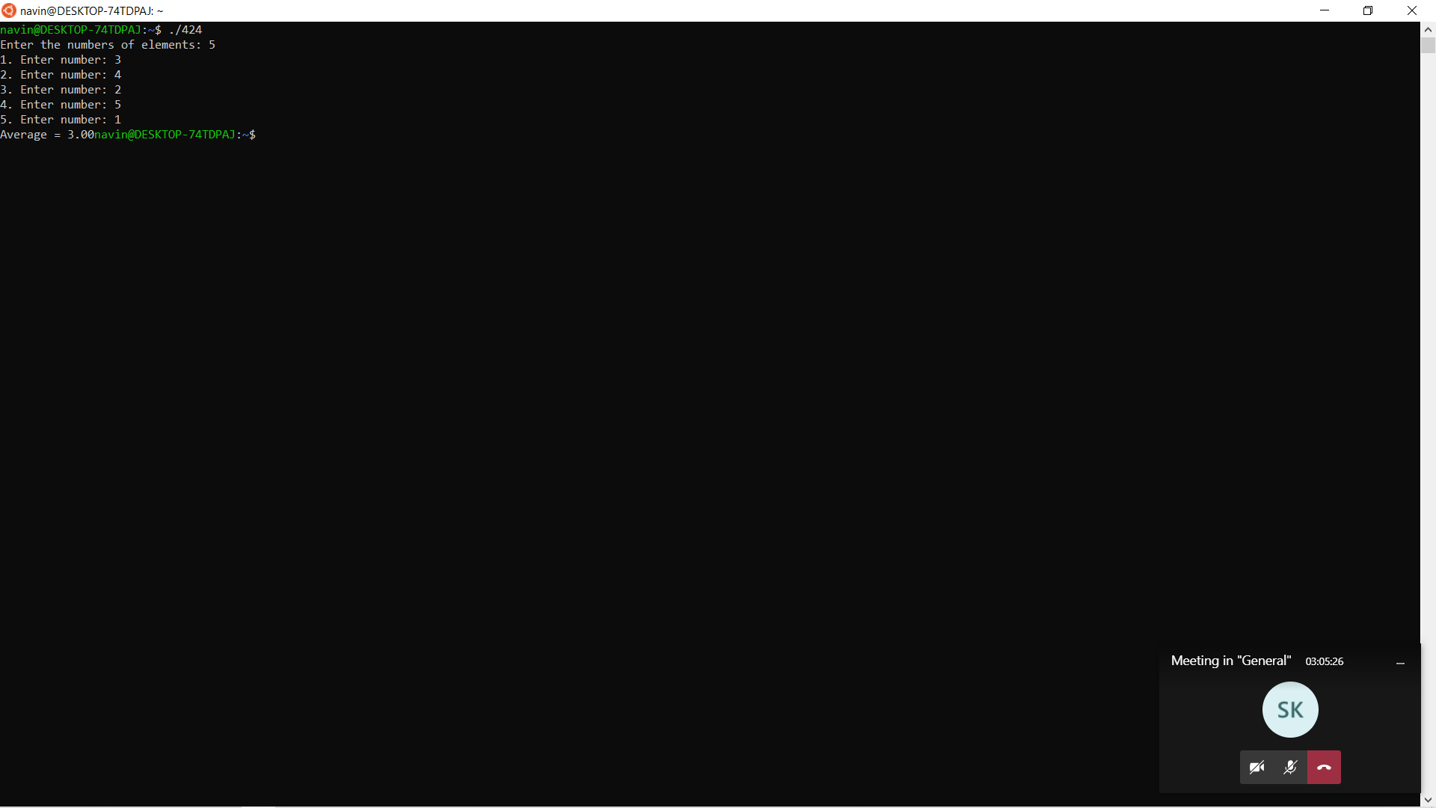

5.Program to find the largest element of an array

#include <stdio.h>

int main()

{

int size, i, largest;

printf("\n Enter the size of the array: ");

scanf("%d", &size);

int array[size];

printf("\n Enter %d elements of the array: \n", size);

for (i = 0; i < size; i++)

{

scanf("%d", &array[i]);

}

largest = array[0];

for (i = 1; i < size; i++)

{

if (largest < array[i])

largest = array[i];

}

printf("\n largest element present in the given array is : %d", largest);

return 0;

}

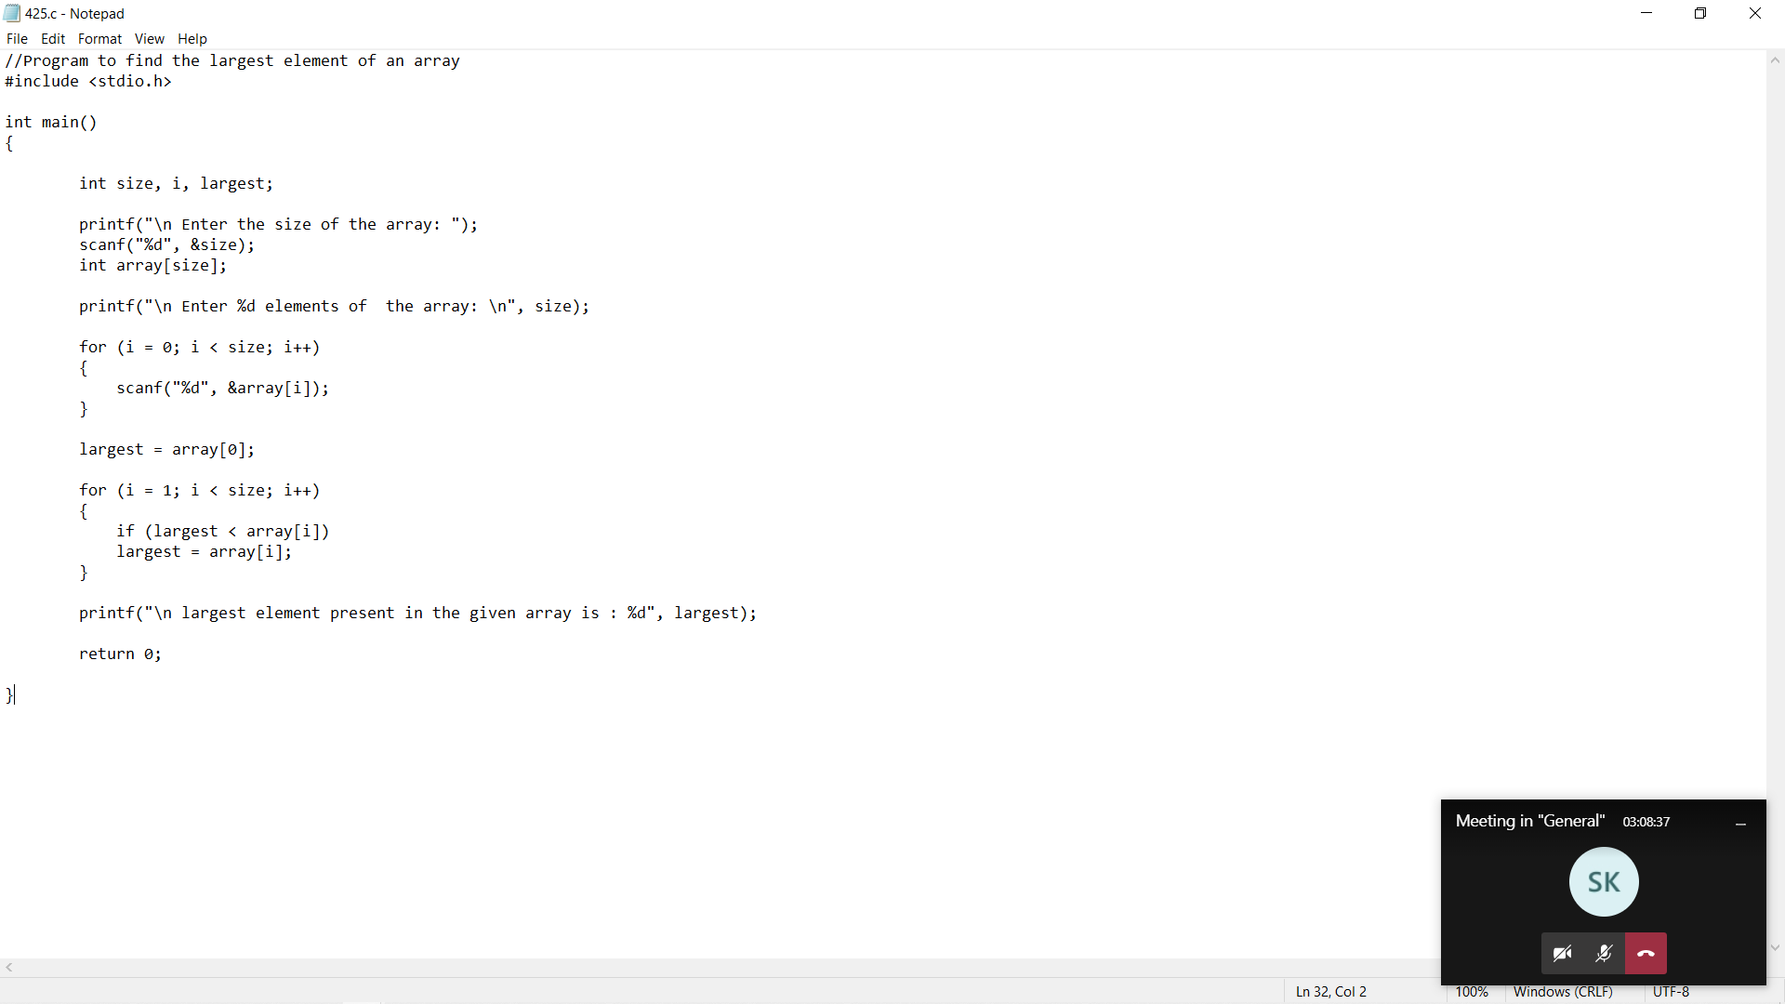

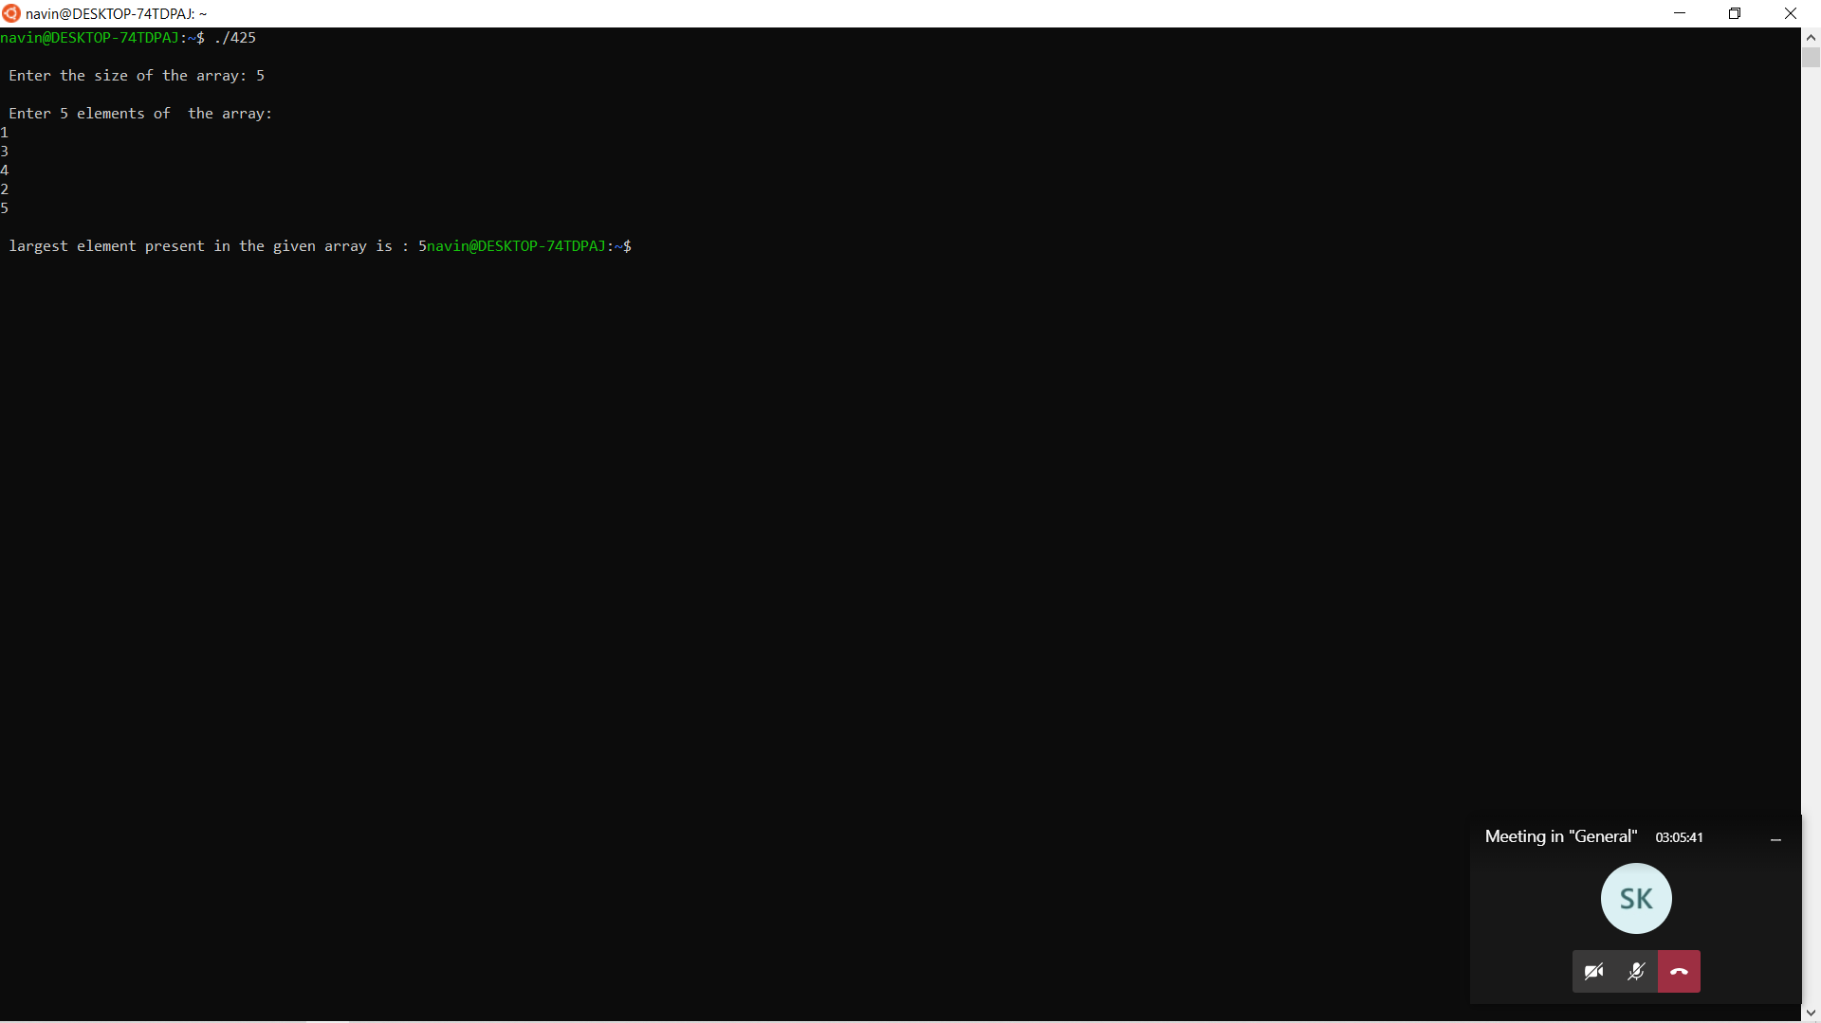

6.C Program to find the smallest element of an array

#include <stdio.h>

int main()

{

int array[100], minimum, size, c, location = 1;

printf("Enter number of elements in array\n");

scanf("%d", &size);

printf("Enter %d integers\n", size);

for (c = 0; c < size; c++)

scanf("%d", &array[c]);

minimum = array[0];

for (c = 1; c < size; c++)

{

if (array[c] < minimum)

{

minimum = array[c];

location = c+1;

}

}

printf("Minimum element is present at location %d and its value is %d.\n", location, minimum);

return 0;

}

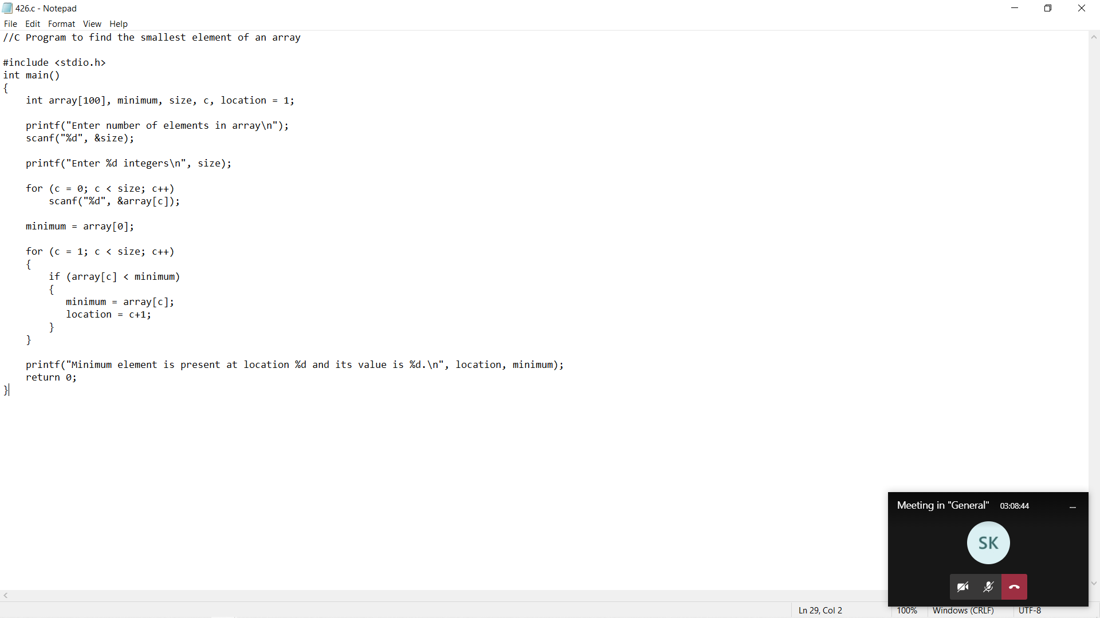

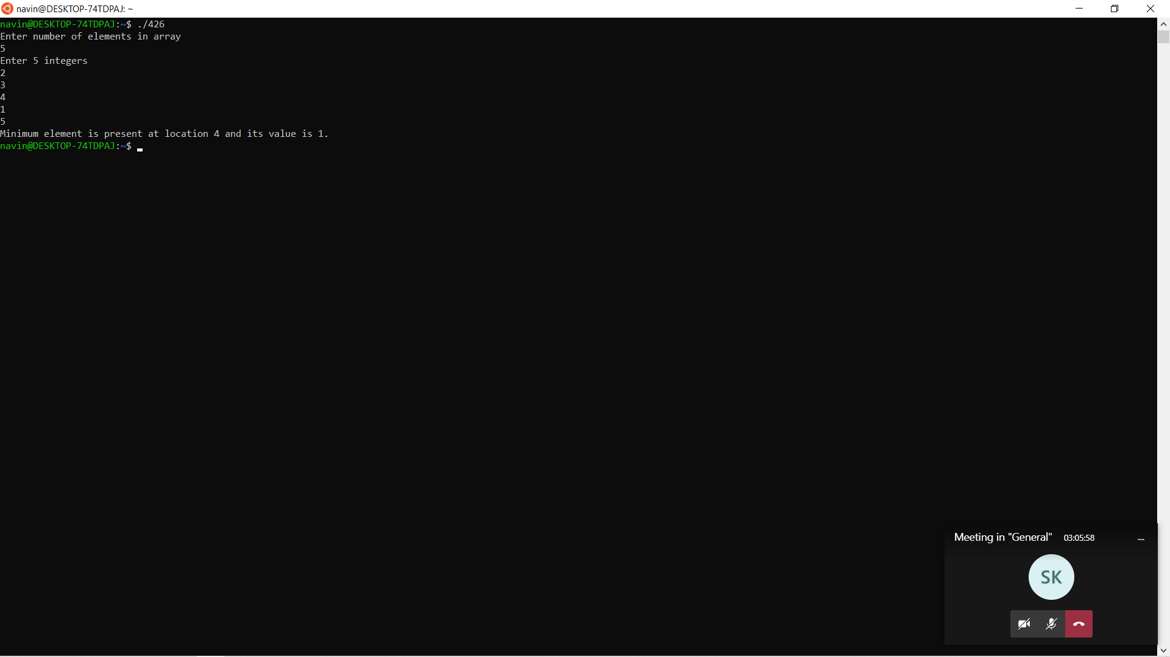

7.C Program to Find the Largest 2 Number in an Array

#include <stdio.h>

int main ()

{

int n = 0, i = 0, largest1 = 0, largest2 = 0, temp = 0;

printf ("Enter the size of the array\n");

scanf ("%d", &n);

int array[n];

printf ("Enter the elements\n");

for (i = 0; i < n; i++)

{

scanf ("%d", &array[i]);

}

printf ("The array elements are : \n");

for (i = 0; i < n; i++)

{

printf ("%d\t", array[i]);

}

printf ("\n");

largest1 = array[0];

largest2 = array[1];

if (largest1 < largest2)

{

temp = largest1;

largest1 = largest2;

largest2 = temp;

}

for (int i = 2; i < n; i++)

{

if (array[i] > largest1)

{

largest2 = largest1;

largest1 = array[i];

}

else if (array[i] > largest2 && array[i] != largest1)

{

largest2 = array[i];

}

}

printf ("The FIRST LARGEST = %d\n", largest1);

printf ("THE SECOND LARGEST = %d\n", largest2);

return 0;

}

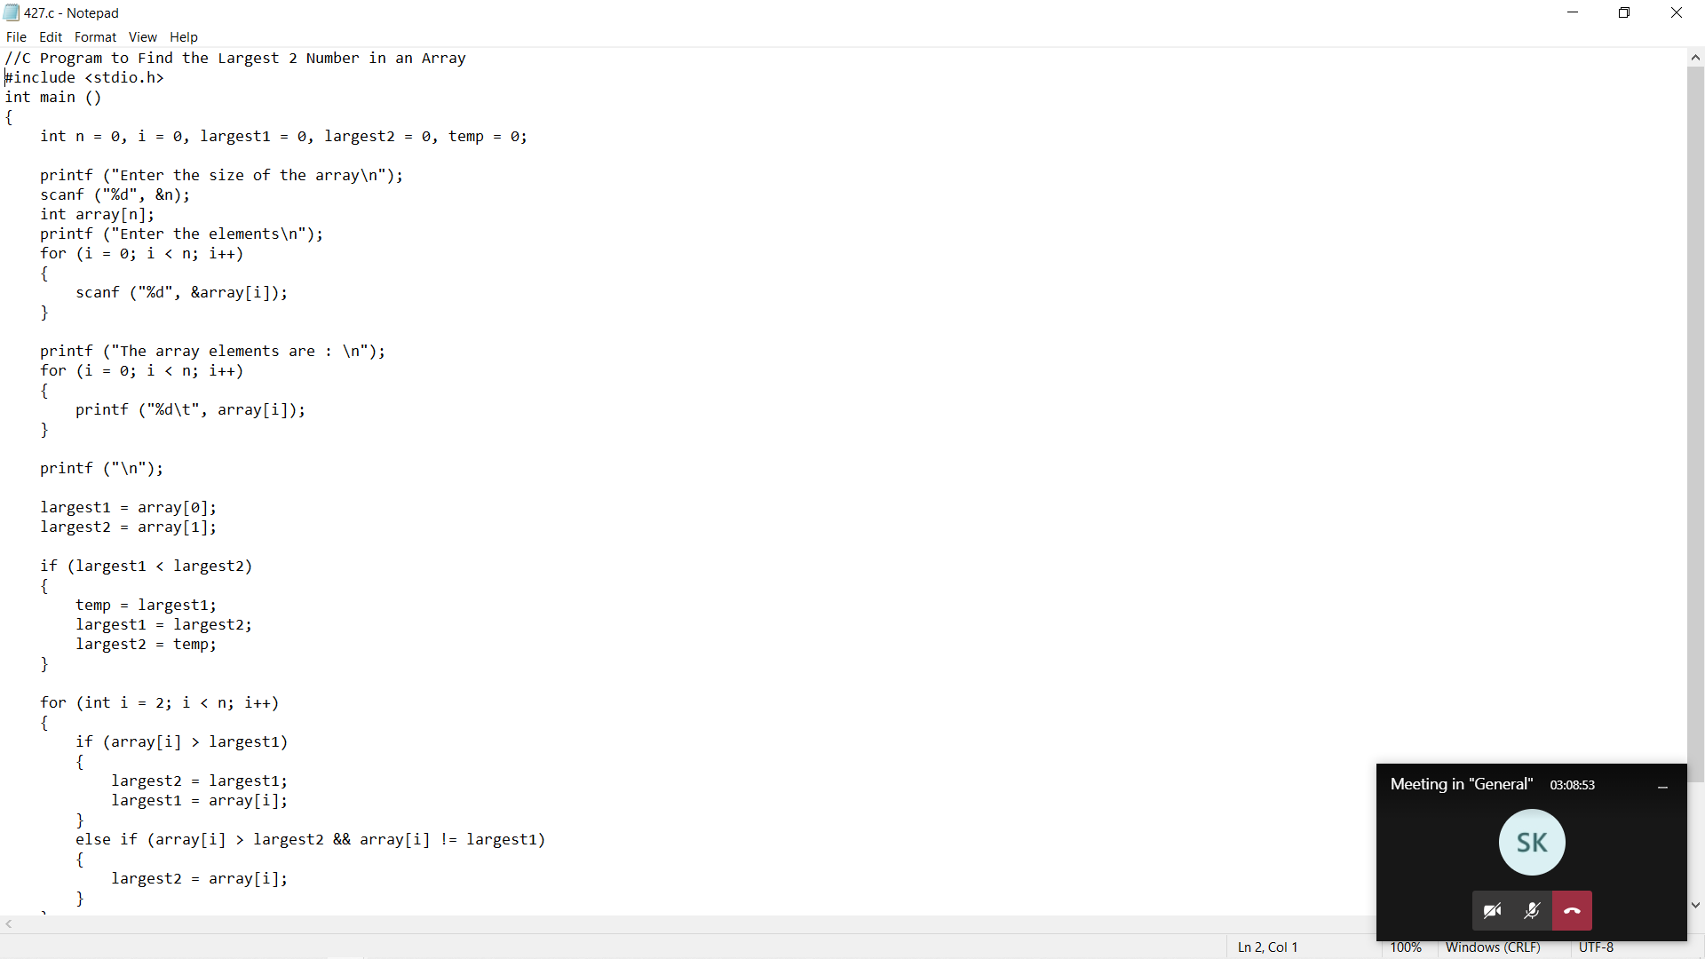

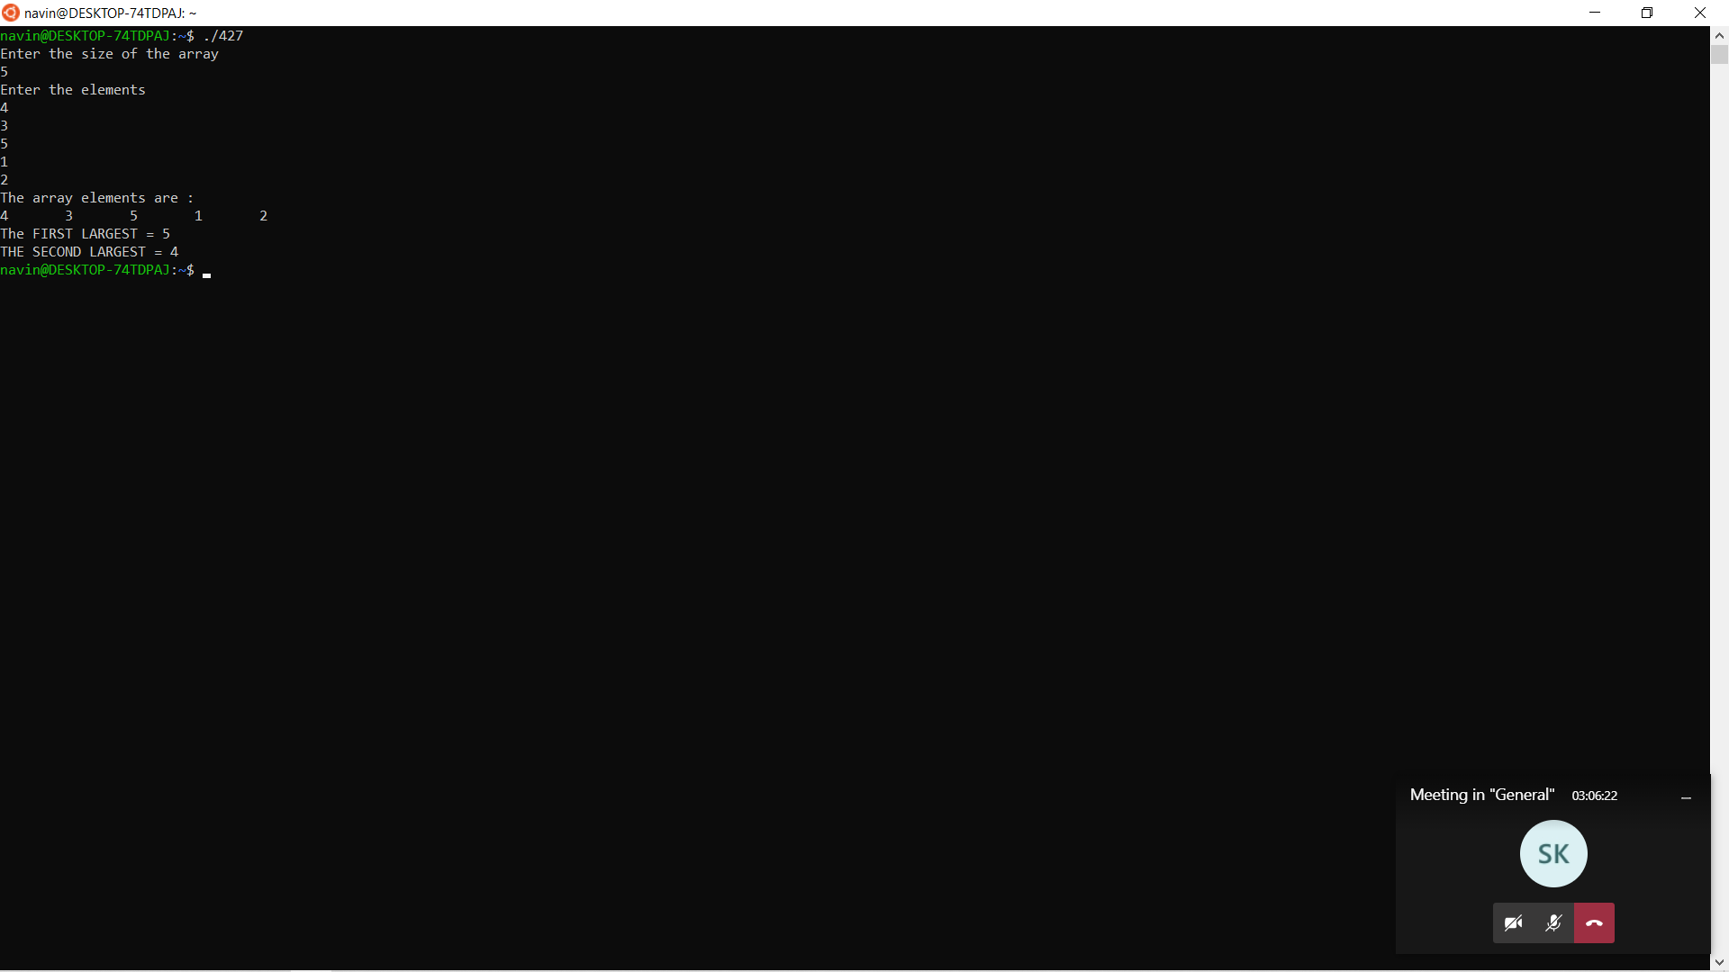

8.C Program to Find the Second Largest & Smallest Elements in an Array

#include <stdio.h>

void main ()

{

int number[30];

int i, j, a, n, counter, average;

printf("Enter the value of N\n");

scanf("%d", &n);

printf("Enter the numbers \n");

for (i = 0; i < n; ++i)

scanf("%d", &number[i]);

for (i = 0; i < n; ++i)

{

for (j = i + 1; j < n; ++j)

{

if (number[i] < number[j])

{

a = number[i];

number[i] = number[j];

number[j] = a;

}

}

}

printf("The numbers arranged in descending order are given below \n");

for (i = 0; i < n; ++i)

{

printf("%d\n", number[i]);

}

printf("The 2nd largest number is = %d\n", number[1]);

printf("The 2nd smallest number is = %d\n", number[n - 2]);

average = (number[1] + number[n - 2]) / 2;

counter = 0;

for (i = 0; i < n; ++i)

{

if (average == number[i])

{

++counter;

}

}

if (counter == 0 )

printf("The average of %d and %d is = %d is not in the array \n",

number[1], number[n - 2], average);

else

printf("The average of %d and %d in array is %d in numbers \n",

number[1], number[n - 2], counter);

}

